Assignment 2

Name - Aaditya Ghosh Reg no - 19BCY10034

Code-

#include<Servo.h>

Servo s;

void setup()

{

Serial.begin(9600);

pinMode(9, OUTPUT); // set arduino pin 9 to output mode

pinMode(10, INPUT); // set arduino pin 10 to input mode

s.attach(7); // attaches the servo on pin 7 to the servo object

s.write(0);

}

void loop()

{

digitalWrite(9, HIGH);

delayMicroseconds(10);

digitalWrite(9, LOW); // generate 10-microsecond pulse to TRIG pin

float dur = pulseIn(10, HIGH);

float dis = (dur\*0.0343)/2; // calculate the distance

if(dis <100)

s.write(90); // rotate servo motor to 90 degree to open garage door

delay(2000);

s.write(0); // rotate servo motor to 0 degree to close garage door

Serial.print("Distance in cm: ");

Serial.println(dis);

}

Screenshot of the design- 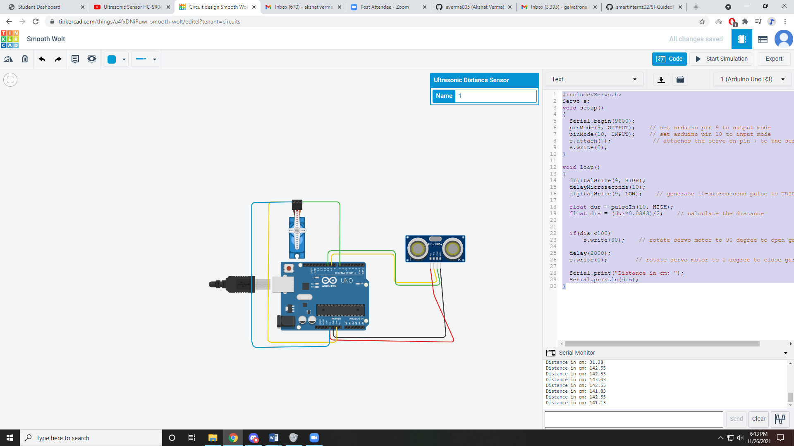

When the distance is more than 100cm-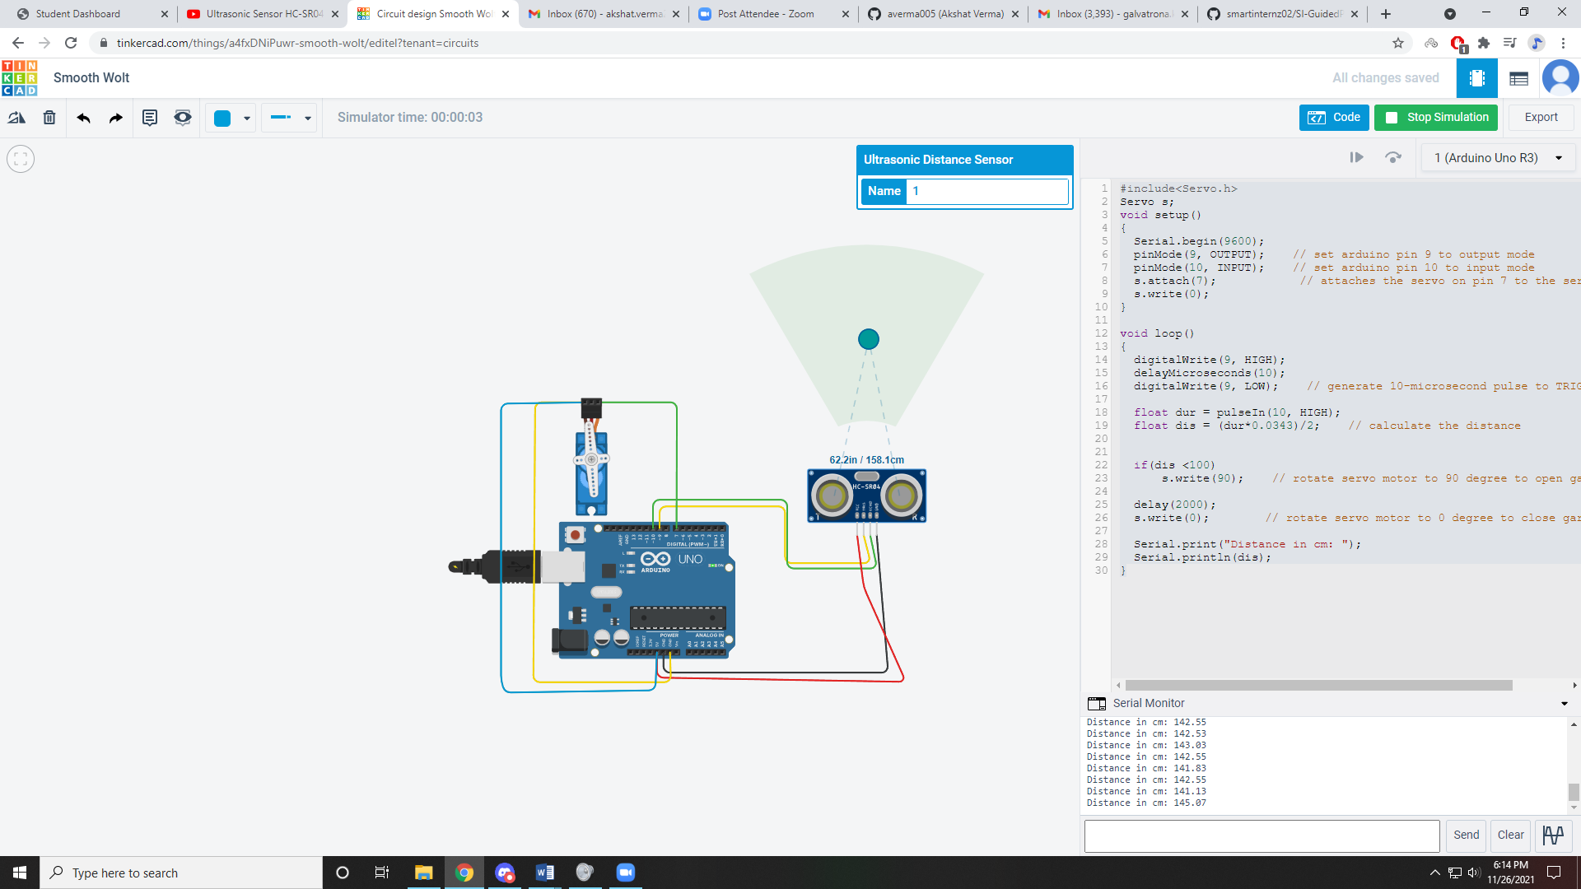

When the distance is less than 100 cm- 